Detecting SQL Injection Attacks Using Machine Learning or Transformer Models

Abstract
SQL injection attacks are critical security vulnerability exploitation in web applications, posing risks to data, if successfully executed, allowing attackers to gain unauthorised access to sensitive data. Due to the absence of a standardised structure, traditional
signature-based detection methods face challenges in effectively detecting SQL injection attacks. To overcome this challenge, machine learning (ML) algorithms have emerged as a promising approach for detecting SQL injection attacks. This paper presents a
comprehensive literature review on the utilisation of ML techniques for SQL injection detection. The review covers various aspects, including dataset collection, feature extraction, training, and testing, with different ML algorithms. The studies included in the review demonstrate high levels of accuracy in detecting attacks and reducing false positives.

In this paper, a machine learning (ML)-based model is proposed for identifying SQLi attacks. The authors propose a two-stage personalized software processing pipeline as a novel element. Although individual techniques are known, their structured combination and application in this context represent a novel approach to transforming raw SQL queries into input features for an ML model. In this research, a dataset consisting of 90,000 SQL queries was constructed, comprising 17,695 legitimate and 72,304 malicious queries. The dataset consists of synthetic data generated using the GPT-4o model and data from a publicly available dataset. These were processed within a pipeline proposed by the authors, consisting of two stages: syntactic normalization and the extraction of the eight semantic features for model training. Also, within the research, several ML models were analyzed using the Azure Machine Learning Studio platform. These models were paired with different sampling algorithms for selecting the training set and the validation set. Out of the 15 training-sampling algorithm combinations, the Voting Ensemble model achieved the best performance. It achieved an accuracy of 96.86%, a weighted AUC of 98.25%, a weighted F1-score of 96.77%, a weighted precision of 96.92%, and a Matthews correlation coefficient of 89.89%. These values demonstrate the model’s ability to classify queries as legitimate or malicious. The attack identification rate was only 15 malicious queries missed out of a total of 7200, and the number of false alarms was 211 cases. The results confirm the possibility of integrating this algorithm into an additional security layer within an existing web application architecture. In practice, the authors suggest adding an extra layer of security using synthetic data.

Introduction
SQL injection (SQLI) attacks are a common type of web application security vulnerability that can allow attackers to execute malicious SQL statements and gain unauthorised access to sensitive data. The increasing complexity of web applications and the need for robust and effective security measures make the use of robust techniques for detecting SQLI attacks. According to OWASP, SQLI is one of the top 10 most critical web application security risks. As shown in Fig.1, SQLI
was recognised as the first most critical risk in their 2017 Top 10 report, with an estimated frequency of roughly 25%. In 2021, it drops to third place, with 94% of applications examined for some sort of injection, with a maximum incidence rate of 19% and an average incidence rate of 3.37 (OWASP, 2021). The lack of a standard structure for SQLI attacks makes it difficult to develop traditional signature-based detection methods that rely on predefined patterns or rules (Demilie & Deriba, 2022). Machine learning (ML) algorithms can overcome this challenge by learning from patterns and relationships in the data, allowing them to detect previously unknown SQLI attacks and adapt to changes in attack techniques over time.

The lack of a standard structure for SQLI attacks makes it difficult to develop traditional signature-based detection methods that rely on predefined patterns or rules (Tadhani et al., 2024). Machine learning (ML) algorithms can overcome this challenge by learning from patterns and relationships in the data, allowing them to detect previously unknown SQLI attacks and adapt to changes in attack techniques over time.

In this paper, our primary objective is to conduct an extensive literature review, systematically comparing various recent research studies that utilise ML algorithms to prevent and detect SQLI attacks. We aim to critically evaluate the feasibility and effectiveness of these algorithms as documented in existing research rather than conducting new experiments. Our goal is to synthesise this information to provide a detailed assessment and classification of different ML models based on their performance in real-time SQLI attack detection and prevention. This analysis will serve as a roadmap, highlighting key findings and insights derived from previous research to guide future studies and developments in this field. This paper will provide valuable insights into the effectiveness of using ML to detect SQLI attacks and contribute to the field of web application security. This paper will also compare the effectiveness and limitations of using different ML models for SQLI detection and suggest directions for future work in this area.

In this research, the aim is to We also examine machine learning (ML) methods as an intermediate layer between input retrieval and query execution, without excluding the classic security layer, ORM, Prepared Statement, Store Procedure, or other SQLi prevention techniques from this ensemble. The authors further recommend the continued use of previously employed security layers, with the introduction of an additional layer that integrates ML components as a second measure to prevent SQLi. In this way, the authors propose training an ML model that captures a series of input features. For training the model, the following research questions (RQs) are posed:

1. How is the dataset constructed for training the model in the context of data privacy compliance?
2. What are the features used in training the model so that it can distinguish between malicious and legitimate queries?
3. Is it feasible to integrate a secondary security layer that uses specific ML methods?
4. How do the metrics obtained from the model relate to practical use?

The authors’ contributions in this research address the following aspects:
- In this research, a software pipeline consisting of two stages was developed. The first normalizes SQL queries at both the syntactic and semantic levels by replacing customized values with standard expressions. In contrast, the second is related to feature extraction, which enables the ML model to generalize to detect SQLi attacks.
- This research proposed a method for generating a synthetic dataset correlated with a public dataset to obtain 90,000 queries. The synthetic dataset was generated using the GPT-4o model. The use of the synthetic dataset excludes the ethical issues associated with using real data.
- The authors proposed eight repetitive features within SQL queries at the semantic and structural level. These characteristics allow differentiation between legitimate and malicious queries.
- This study trained and evaluated ML algorithms by analyzing their performance. In the research, five ML algorithms were analyzed in conjunction with three sampling algorithms to perform the selection of training data versus validation data.
- This study identified the model with the best performance metrics and integrated it into a security architecture applied within web applications as an additional layer to traditional protection mechanisms.
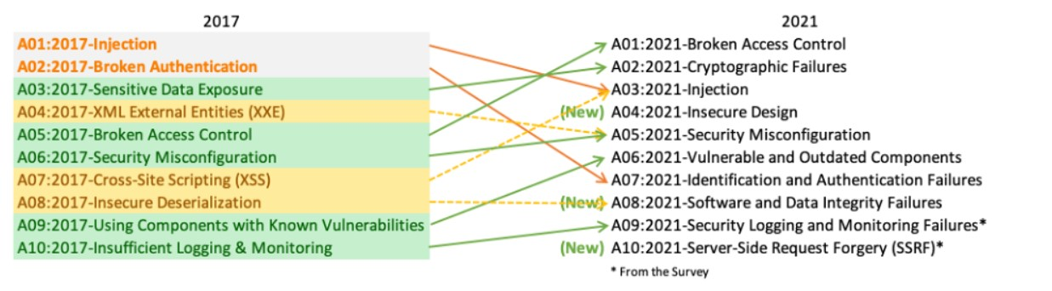
Fig. 1. SQLIA OWASP ranking in 2017 and 2021 (OWASP, 2021).

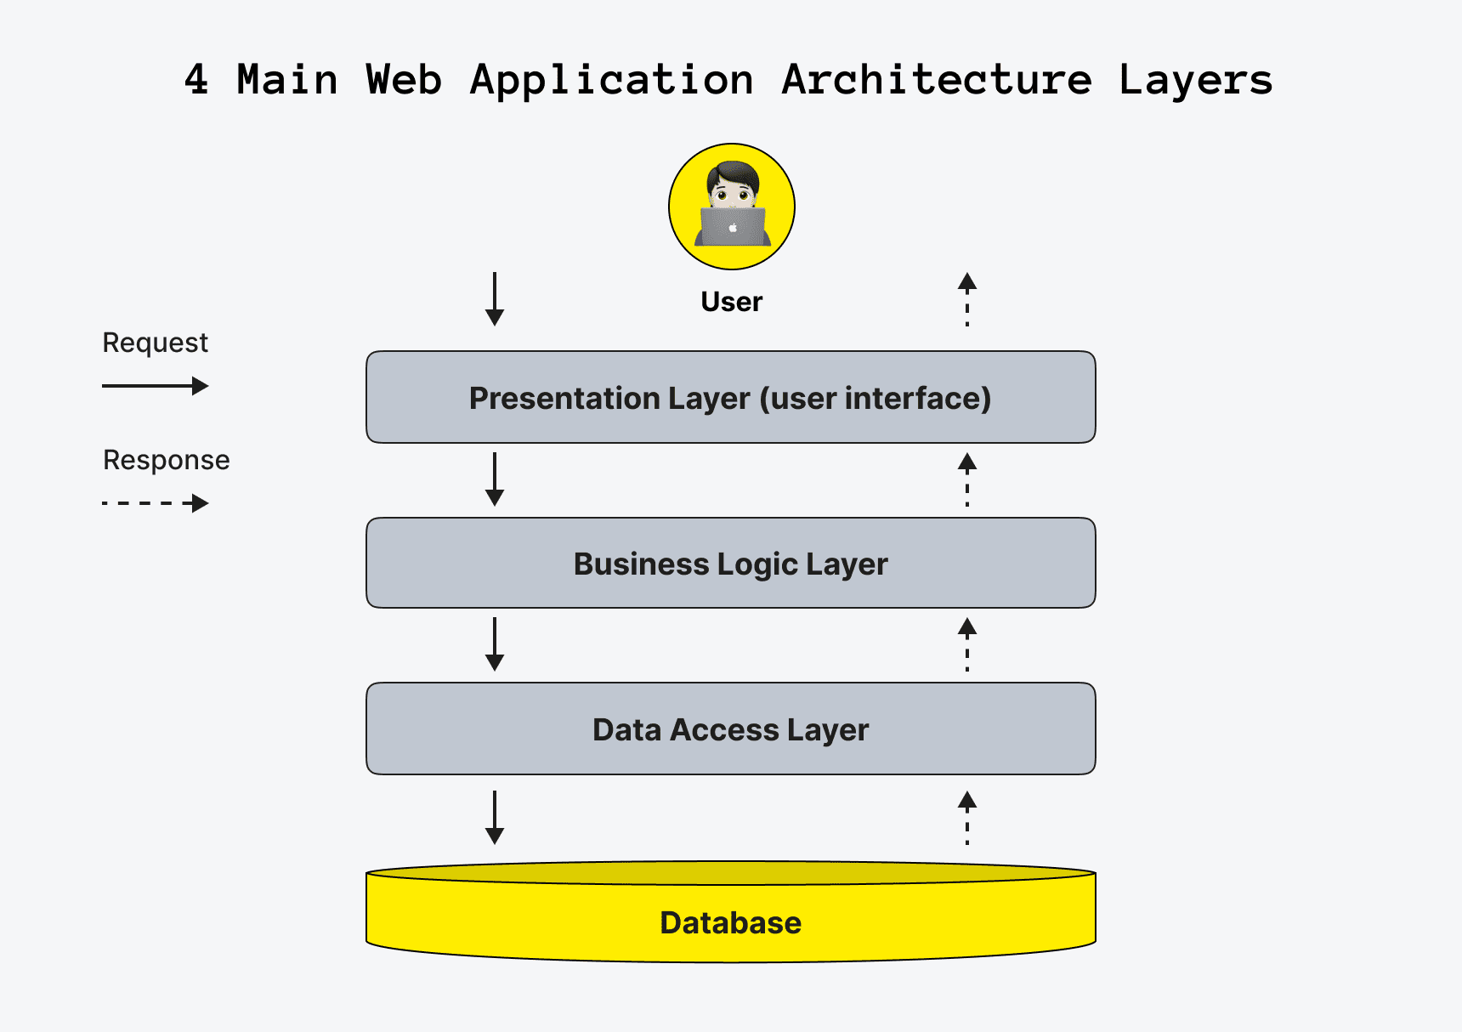

Literature Review
Machine learning and artificial intelligence have made a big impact on SQL injection (SQLi) detection, encouraging cybersecurity experts to investigate different security solutions Akash et al., (2022). In Qiu et al.’s (2018) paper Qiu et al., (2019), AI tools in addressing different threats and their countermeasures, including topics on natural language, digital image analysis, cybersecurity findings and strategies to stop certain forms of attack on warfare, were examined. On top of this basis, Martins et al., (2019) Martins et al., (2020) examined over 15 studies that applied adversarial machine learning to intrusion and malware detection and summarized the typical kinds of attacks and defense efforts, forming a basis for understanding the interactions between attackers and defenders in cyberspace (Fuster-Guillén et al., 2023). Alhowiti and Mohamed [1] classify existing detection solutions into prevention methods based on input validation and parameterization through Object-Relational Mapping (ORM) techniques and stored procedures. Alhowiti and Mohamed (2025) classify existing detection solutions into prevention methods based on input validation and parameterization through Object-Relational Mapping (ORM) techniques and stored procedures (Alhowiti & Mohamed, 2025). A second approach targets defense mechanisms, such as runtime detection. For example, Jang (2020) addresses the detection of SQLi vulnerabilities in the context of SQL queries directly embedded in the programming language. This is an area not covered by traditional methods, proposing the generation of candidate code that detects SQL injections in the source code at runtime (Rosca & Stancu, 2025). Yuan et al. (2023) introduce a tool based on static analysis for applications that use object-oriented database extensions. The method involves code transformation, meaning the conversion of object-oriented code into equivalent procedural code and detection using control flow graphs and tight analysis. Among the earlier studies, Muslihi et al. (2020) investigated the use of 14 deep learning approaches for SQLi detection and showed they are relevant, having analyzed the features, datasets, objectives and implementation strategies (Muslihi & Alghazzawi, 2020). Continuing this area of research, Muhammad et al., (2021) analyzed 82 papers that focus on SQLi detection and mitigation, noting that development of innovative techniques is common but teams rarely test different systems against each other and do not provide enough real-world testing data (Aliero et al., 2020). In their work, Krishnan et al. (2021) presented a practical framework for finding SQLi faults on the client side using five ML classifiers, including CNN. Their study found that CNN had the best results, detecting such faults with 97% accuracy (Krishnan et al., 2021).
The security of web applications is studied through SQLi attacks, as they represent some of the most dangerous threats to data protection through different AI methods (Alghawazi et al., 2022; Farooq, 2021; Shareef et al., 2023; Rosca et al., 2025). In the specialized literature, SQLi attacks are studied using ML algorithms to detect potential security breaches. Identifying repetitive features is one of the challenges faced by ML models in the context of SQLi.
Arasteh et al. (2024) used feature selection methods combined with classifiers such as Artificial Neural Networks. Thus, in Arasteh et al. (2024a), the authors achieved an accuracy of 99.35%, while in Arasteh et al. (2024b), the authors obtained an accuracy of 99.68%, for a dataset consisting of 13 features. The two studies focus on optimizing the features used in training with ML algorithms.
Other research addresses deep learning (DL) models for automated feature engineering (Rosca & Stancu, 2026). For example, Thalji et al. (2023) combine the autoencoder model with Extreme Gradient Boosting (XGBoost) to achieve an accuracy of 99%, while Alghawazi et al. (2023) employ a Recurrent Neural Network (RNN) autoencoder to achieve an accuracy of only 94% in SQLi detection. The Probabilistic Neural Network (PNN) model is also investigated for the same purpose (Alarfaj & Khan, 2023), achieving an accuracy of 99.19%. Other techniques achieved an accuracy of 98.02% in the paper by Muduli et al. (2024) and over 99.8% in the paper by Bakır (2025). There are researchers who use Natural Language Processing (NLP) (Lo et al., 2025; Rosca et al., 2025) or combinations of models such as CNN plus Long Short-Term Memory (LSTM), achieving an accuracy of 99.84% (Tadhani et al., 2024).
A significant number of essential gaps continue to exist in the research of using machine learning to detect SQL injection (SQLI). Research studies mainly attempt to enhance detection accuracy while neglecting to provide transparency about decision-making processes which security administrators need for analysis. Research into data imbalance problems and model overfitting risks that affect detection robustness remains inadequate despite the examination of different machine learning techniques. The majority of research analyzes models through single-dataset evaluation leading to questions about their capability to identify various SQLI attack patterns. Most of the examined works fail to consider real-time deployment through their analysis since they test detection performance in offline settings without addressing latency aspects or computational efficiency in actual live deployments.
Analyzing the existing studies in the literature, it is found that the accuracy achieved in the proposed models for SQLi attack detection is high, reaching up to 99.8%. Although these values demonstrate the possibility of integrating the model in practice, most research relies on controlled datasets, which have well-defined scenarios and lead to limitations in applicability in realistic contexts, especially since these datasets use data that do not always have usage rights. Given these limitations, this research investigates ML models that maintain the performance observed in the literature, but the dataset is adapted to a variable environment, using synthetic data for which privacy rules do not need to be applied, and which acts as an additional layer in production web applications.

Methodology
To address the research questions, the study considers that SQL injection (SQLi) attacks typically introduce abnormal patterns into otherwise valid SQL queries. These patterns often include additional logical expressions or conditions that enable unauthorized access to data.
For dataset construction, a hybrid approach was used, combining a public dataset with synthetically generated data (AlexTrinity, 2022). Both datasets follow a consistent structure, where the first column contains the SQL query (user input), and the second column indicates whether the query is malicious or legitimate. Additional attributes, such as SQL command type, target table, operators, and query components, are also included to enrich the dataset, as shown in the provided schema.
A key advantage of this approach is that it avoids the use of sensitive or confidential data, ensuring privacy and security. The synthetic data were generated using GPT-4o, enabling the creation of realistic SQL queries that replicate both normal behavior and attack patterns.
The generated dataset includes labeled queries that support the classification task, helping machine learning models distinguish between benign and malicious inputs. Moreover, the use of synthetic data allows for better control over class distribution, making it possible to construct a balanced dataset, which is essential for improving model performance and reducing bias.

Data Discription
For SQL injection detection, this study is based on two publicly available datasets from Mendelay Data and Kaggle. The initial dataset is labelled as the "Rule-Based SQL Injection" (RbSQLi) which has been developed to support advanced research and development in the detection of SQL injection (SQLi) vulnerabilities. It contains a total of 10,190,450 structured entries, out of which 2,699,570 are labeled as malicious and 7,490,880 as benign.
The second is a public dataset with 17,695 legitimate queries from the SQL-Injection-Extend dataset (Kaggle) (AlexTrinity, 2022).
The aforementioned datasets have a variety of SQL injection patterns, and are thus suitable to test the robustness of various machine learning models. For reliability assurance, however, quality checks on data were also performed to remove duplicate entries and ensure balanced representation of different attack types, in case of discrepancies

Data Preprocessing
Preprocessing is a critical step in preparing the datasets for effective model training. Several techniques were employed:
1) Data Cleaning and Transformation
Handling Missing Values: The datasets were examined for missing values, which were either removed or imputed to maintain data integrity.
Text Normalization: Queries were converted to lowercase to standardize input formats. Punctuation marks were removed to prevent noise variations. However, to balance normalization with feature retention, special characters that frequently appear in SQL queries (such as SELECT, INSERT, and DELETE) were preserved unless deemed unnecessary for classification.
Removal of Typical SQL Keywords: Some common SQL keywords were removed to reduce redundancy and enhance model performance. However, care was taken to retain essential keywords that contribute to attack patterns. A comparative analysis was conducted to ensure that feature reduction did not adversely impact detection accuracy.
Tokenization and Stemming: Tokenization was applied to break down SQL queries into individual components, facilitating better feature extraction. The Porter Stemmer was employed to reduce words to their root forms, allowing the model to generalize across variations in query syntax.

REFERENCES

[1] "OWASP Top10 - 2021," 2021. [Online]. Available: https://owasp.org/Top10/. [Accessed 14 May 2023].

[26] W.B. Demilie, F.G. Deriba, Detection and prevention of SQLI attacks and developing compressive framework using machine learning and hybrid techniques. J Big Data 9, 124 (2022). DOI: 10.1186/s40537-022-00678-0.

[33] Muslihi, M. T., & Alghazzawi, D. (2020, October). Detecting SQL injection on web application using deep learning techniques: a systematic literature review. In 2020 Third International Conference on Vocational Education and Electrical Engineering (ICVEE) (pp. 1-6). IEEE.

[23] Krishnan, S. A., Sabu, A. N., Sajan, P. P., & Sreedeep, A. L. (2021). SQL injection detection using machine learning. Revista Geintec-Gestao Inovacao E Tecnologias, 11(3), 300-310.

[1] Alhowiti, A.H.; Mohamed, A.M.A. A New Database Integrity Protection Approach Against SQL Injection Attacks (SQLIAs). In Proceedings of the 4th International Conference on Computing and Information Technology, Tabuk, Saudi Arabia, 13–14 April 2025; pp. 507–512. [Google Scholar] [CrossRef]
[2] Jang, Y.-S. Detection of SQL Injection Vulnerability in Embedded SQL. IEICE Trans. Inf. Syst. 2020, E103.D, 1173–1176. [Google Scholar] [CrossRef]
[3] Rosca, C.-M.; Stancu, A. A Comprehensive Review of Machine Learning Models for Optimizing Wind Power Processes. Appl. Sci. 2025, 15, 3758. [Google Scholar] [CrossRef]
[4] Yuan, Y.; Lu, Y.; Zhu, K.; Huang, H.; Yu, L.; Zhao, J. A Static Detection Method for SQL Injection Vulnerability Based on Program Transformation. Appl. Sci. 2023, 13, 11763. [Google Scholar] [CrossRef]

9. Alghawazi, M.; Alghazzawi, D.; Alarifi, S. Detection of SQL Injection Attack Using Machine Learning Techniques: A Systematic Literature Review. J. Cybersecur. Priv. 2022, 2, 764–777. [Google Scholar] [CrossRef]

10. Farooq, U. Ensemble Machine Learning Approaches for Detection of SQL Injection Attack. Tehnički Glasnik 2021, 15, 112–120. [Google Scholar] [CrossRef]

11. Shareef, O.S.F.; Hasan, R.F.; Farhan, A.H. Analyzing SQL payloads using logistic regression in a big data environment. J. Intell. Syst. 2023, 32, 20230063. [Google Scholar] [CrossRef]

12. Rosca, C.-M.; Stancu, A.; Iovanovici, E.M. The New Paradigm of Deepfake Detection at the Text Level. Appl. Sci. 2025, 15, 2560. [Google Scholar] [CrossRef]

13. Arasteh, B.; Bouyer, A.; Sefati, S.S.; Craciunescu, R. Effective SQL Injection Detection: A Fusion of Binary Olympiad Optimizer and Classification Algorithm. Mathematics 2024, 12, 2917. [Google Scholar] [CrossRef]

14. Arasteh, B.; Aghaei, B.; Farzad, B.; Arasteh, K.; Kiani, F.; Torkamanian-Afshar, M. Detecting SQL injection attacks by binary gray wolf optimizer and machine learning algorithms. Neural Comput. Appl. 2024, 36, 6771–6792. [Google Scholar] [CrossRef]

18. Rosca, C.-M.; Stancu, A. Quality assessment of GPT-3.5 and Gemini 1.0 Pro for SQL syntax. Comput. Stand. Interfaces 2026, 95, 104041. [Google Scholar] [CrossRef]
19. Thalji, N.; Raza, A.; Islam, M.S.; Samee, N.A.; Jamjoom, M.M. AE-Net: Novel Autoencoder-Based Deep Features for SQL Injection Attack Detection. IEEE Access 2023, 11, 135507–135516. [Google Scholar] [CrossRef]
20. Alghawazi, M.; Alghazzawi, D.; Alarifi, S. Deep Learning Architecture for Detecting SQL Injection Attacks Based on RNN Autoencoder Model. Mathematics 2023, 11, 3286. [Google Scholar] [CrossRef]
21. Alarfaj, F.K.; Khan, N.A. Enhancing the Performance of SQL Injection Attack Detection through Probabilistic Neural Networks. Appl. Sci. 2023, 13, 4365. [Google Scholar] [CrossRef]
22. Muduli, D.; Shookdeb, S.; Zamani, A.T.; Saxena, S.; Kanade, A.S.; Parveen, N.; Shameem, M. SIDNet: A SQL Injection Detection Network for Enhancing Cybersecurity. IEEE Access 2024, 12, 176511–176526. [Google Scholar] [CrossRef]
23. Bakır, R. UniEmbed: A Novel Approach to Detect XSS and SQL Injection Attacks Leveraging Multiple Feature Fusion with Machine Learning Techniques. Arab. J. Sci. Eng. 2025, 1–14. [Google Scholar] [CrossRef]
24. Lo, R.-T.; Hwang, W.-J.; Tai, T.-M. SQL Injection Detection Based on Lightweight Multi-Head Self-Attention. Appl. Sci. 2025, 15, 571. [Google Scholar] [CrossRef]
25. Rosca, C.-M.; Stancu, A.; Tănase, M.R. A Comparative Study of Azure Custom Vision Versus Google Vision API Integrated into AI Custom Models Using Object Classification for Residential Waste. Appl. Sci. 2025, 15, 3869. [Google Scholar] [CrossRef]
26. Tadhani, J.R.; Vekariya, V.; Sorathiya, V.; Alshathri, S.; El-Shafai, W. Securing web applications against XSS and SQLi attacks using a novel deep learning approach. Sci. Rep. 2024, 14, 1803. [Google Scholar] [CrossRef]

54. AlexTrinity. Kaggle. SQL-Injection-Extend. 2022. Available online: https://www.kaggle.com/datasets/alextrinity/sqlinjectionextend/data (accessed on 4 June 2025).

